Plug-in Name

Enter general description / introduction of the plug-in here.

Plug-in Configuration

Enter general description / introduction of the plug-in here.

To define the Plug-In as a subsystem for Test SLATE:
- From the System Explorer, click Subsystem. Plug-in is listed.
- Right click on Plug-in, a submenu is displayed.
- From this submenu you can Add a Source or Refresh the subsystem.
- Right click on Plug-in and select to Add a source from the submenu. A new Source will be added.
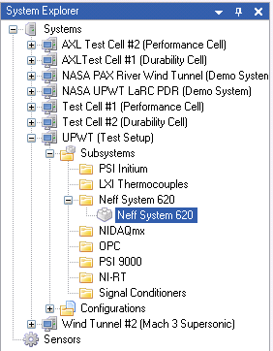

5. To …
Option | Description

Plug-in Calibration

Enter general description / introduction of the plug-in here.
To initiate a calibration:

